**Infrared Thermometer Project**

**2019**

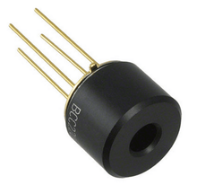

**Harry Schomberg**

**Alondra Thompson**

**Becca Hartman**

**Justin Ayres**

**2019 Infrared Thermometer Project**

**Background:**

Water and heat stress can significantly affect crop production and yield (Fisher & Kebede, 2010). This study is based on the concept that the internal temperature of corn plants fluctuates with moisture and heat-induced stress. Whole plant temperature can be evaluated using canopy and leaf temperature.

Infrared thermometer (IRT) sensors are low-cost sensors (~$12-20), and are employed in this study for many additional reasons. For example, they do not harm the plant because they have no need for physical contact with plant (Mahan & Yeater, 2008). They also allow for simple data collection and easily work with microcontroller boards. Furthermore, their non-point measurements account for spatial variability, obtaining the temperature over an area instead of a single point. They can be a reliable and cost-effective alternative to other similar plant, soil, heat and water stress study techniques.

**Introduction:**

The IRT monitoring system consists of multiple field data logger/transmitter boards, with three IRT sensors attached to a board, monitoring a leaf of a corn plant, canopy temperature, and soil temperature. Temperature measurements are time-stamped and stored in non-volatile “flash” memory. These boards (“clients”) send data hourly to a single central receiver (“server”) which stores the data to non-volatile memory. At the end of each day, the server automatically downloads and stores this data onto an SD card.

The **objective** of this study is to develop a method to measure plant leaf, canopy area, and soil temperature in corn fields and correlate it with soil moisture content.

**Design**

*Description of the device*

Infrared thermometers will be used to measure plant leaf temperature, canopy area temperature, and soil temperature in the field. Each IRT measures both air temperature and object temperature. The data logger consists of a micro-controller, real-time clock/calendar, and circuitry for interfacing and reading sensors. The device is equipped with three IRTs, two with a 35˚ viewing angle and one with a 90˚ viewing angle. The circuits are housed in the middle of the structure as shown in Figure 1.

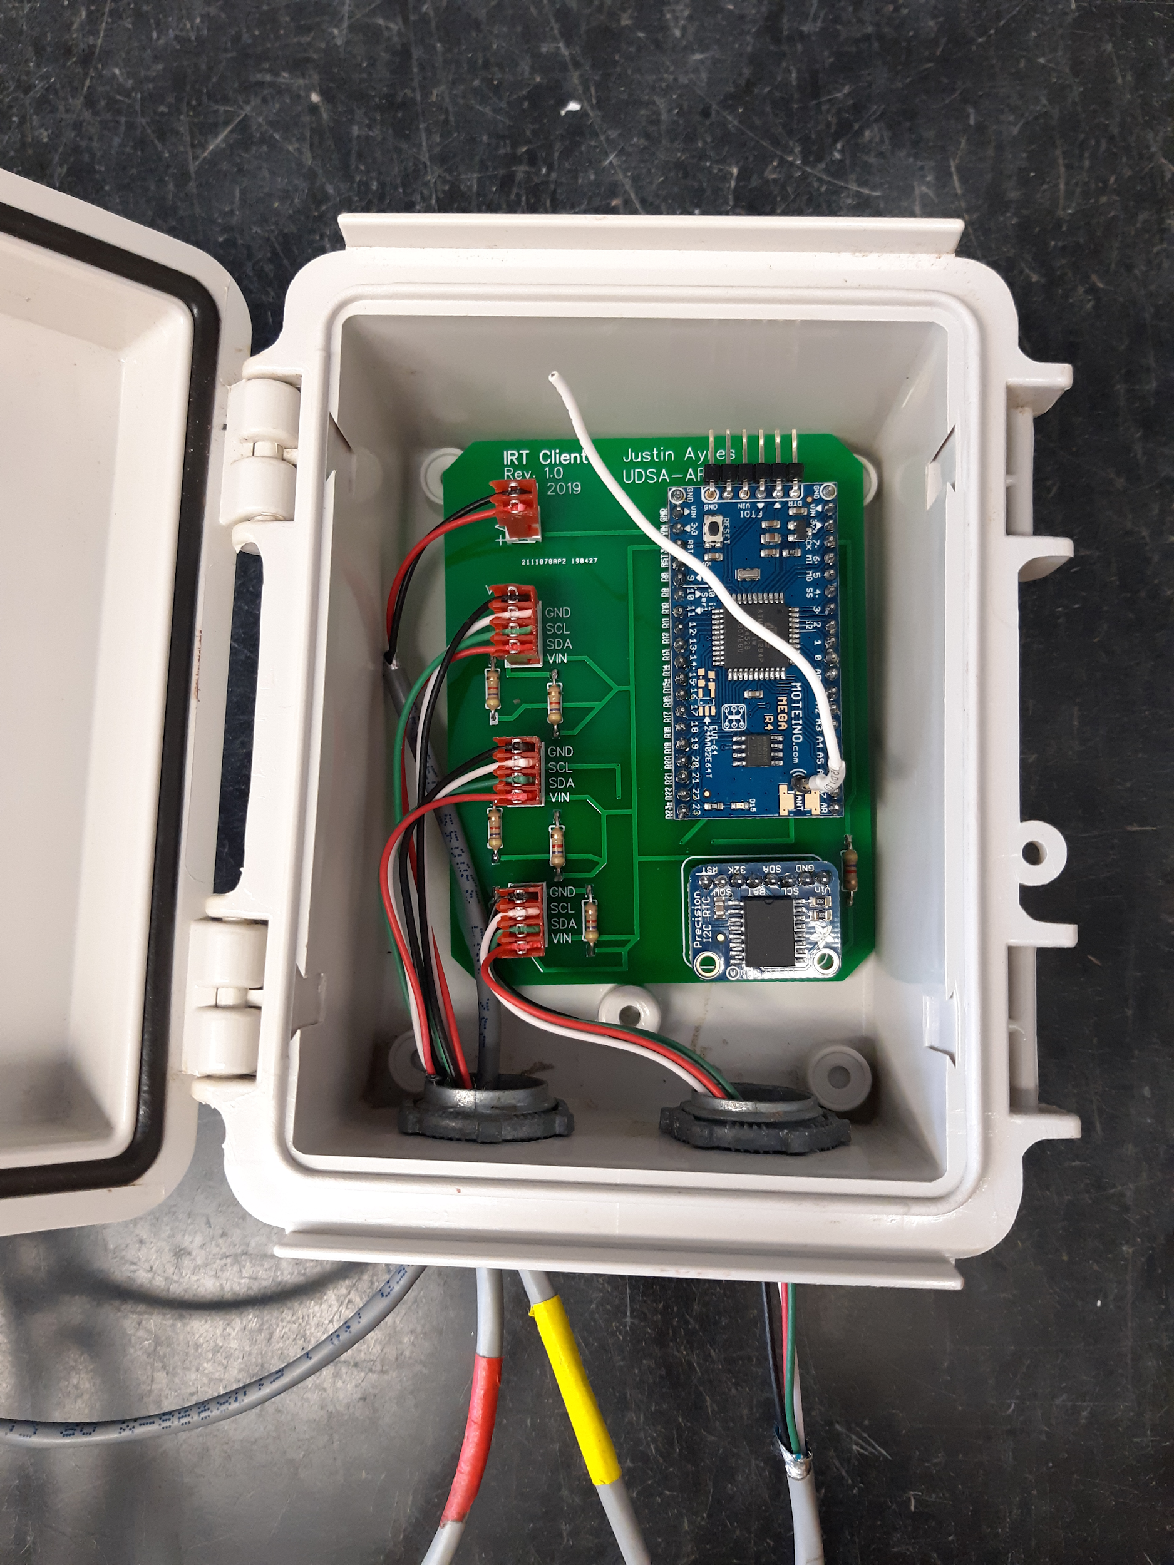

Figure 1. Circuitry inside enclosure

*Structure*

The IRTs are mounted and attached to a PVC structure that consists of a PVC “mast” with a long, rotatable arm for the canopy sensor (Figure 2). This structure is reinforced with a metal pole inside the mast to increase stability.

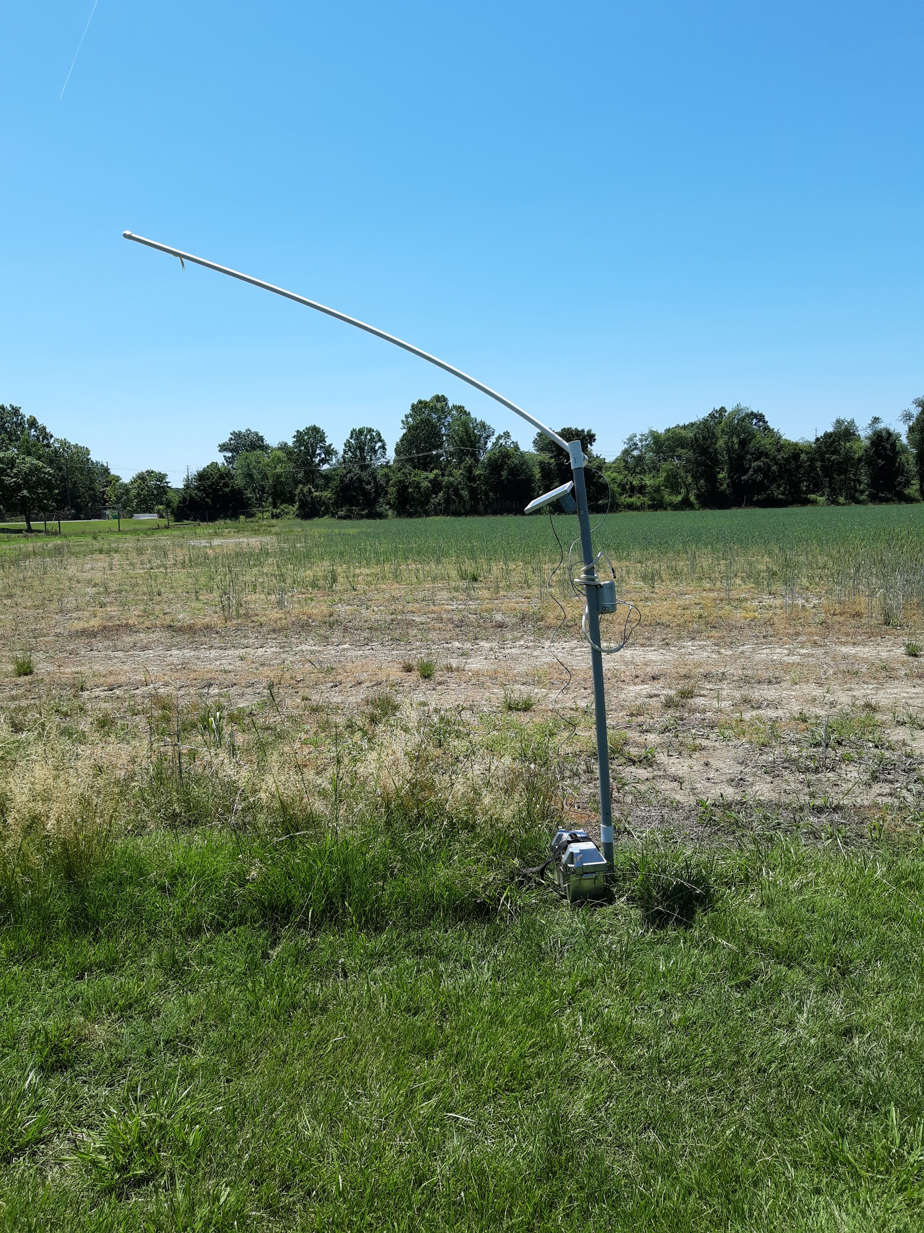

Figure 2. PVC IRT Structure

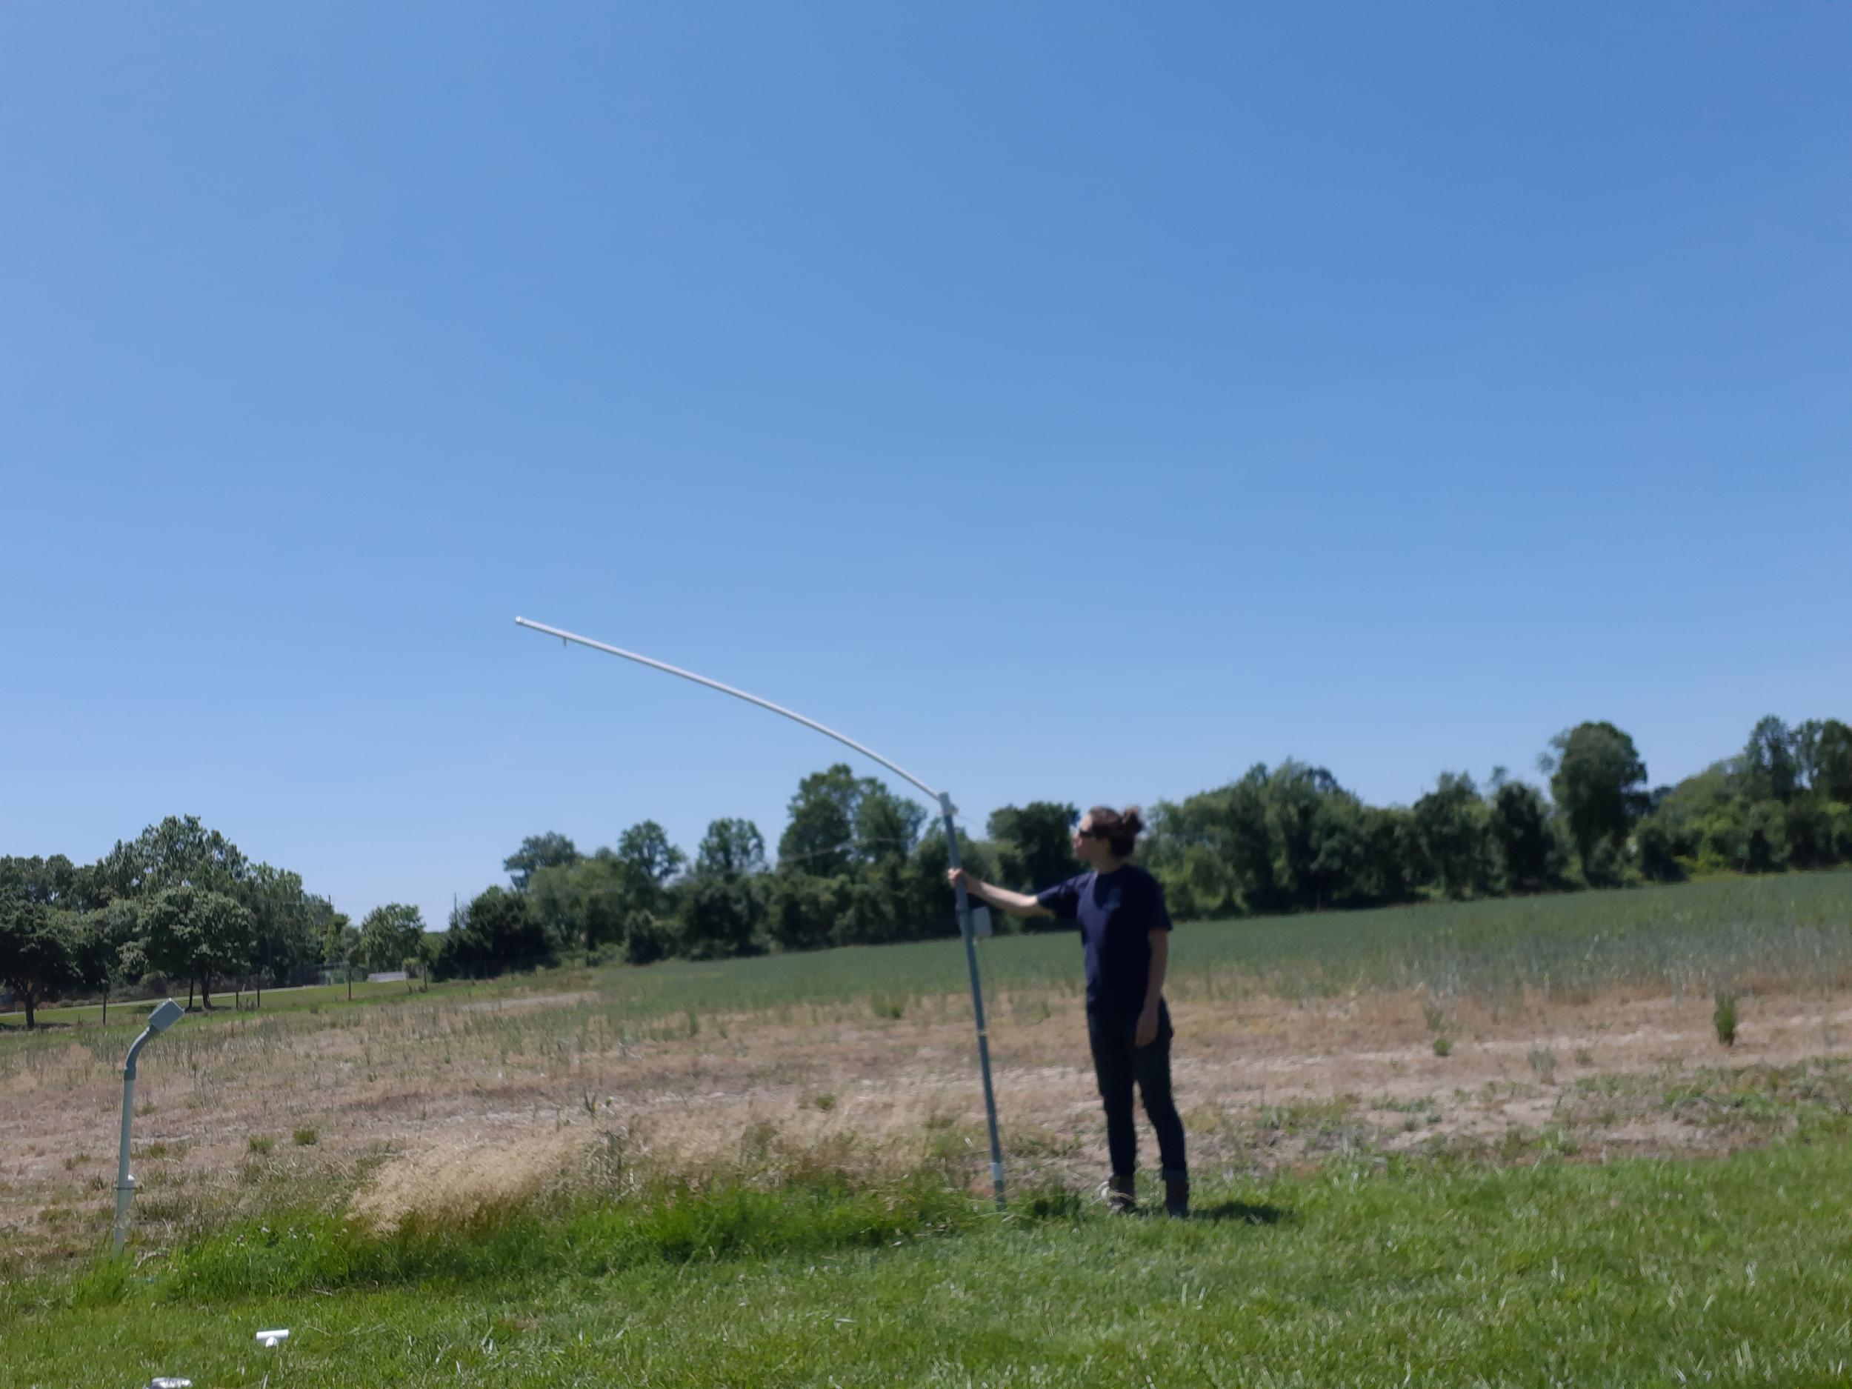

Figure 3. PVC IRT structure (person for scale)

*Sensor attachments*

One 90˚ sensor is attached to the end of the canopy arm to measure the canopy temperature (Figure 4), one sensor (35˚) will be wrapped around the corn plant and aimed at a leaf (Figure 5), and one 35˚ infrared sensor is placed on the lower level of the structure to measure the soil temperature (Figure 6).

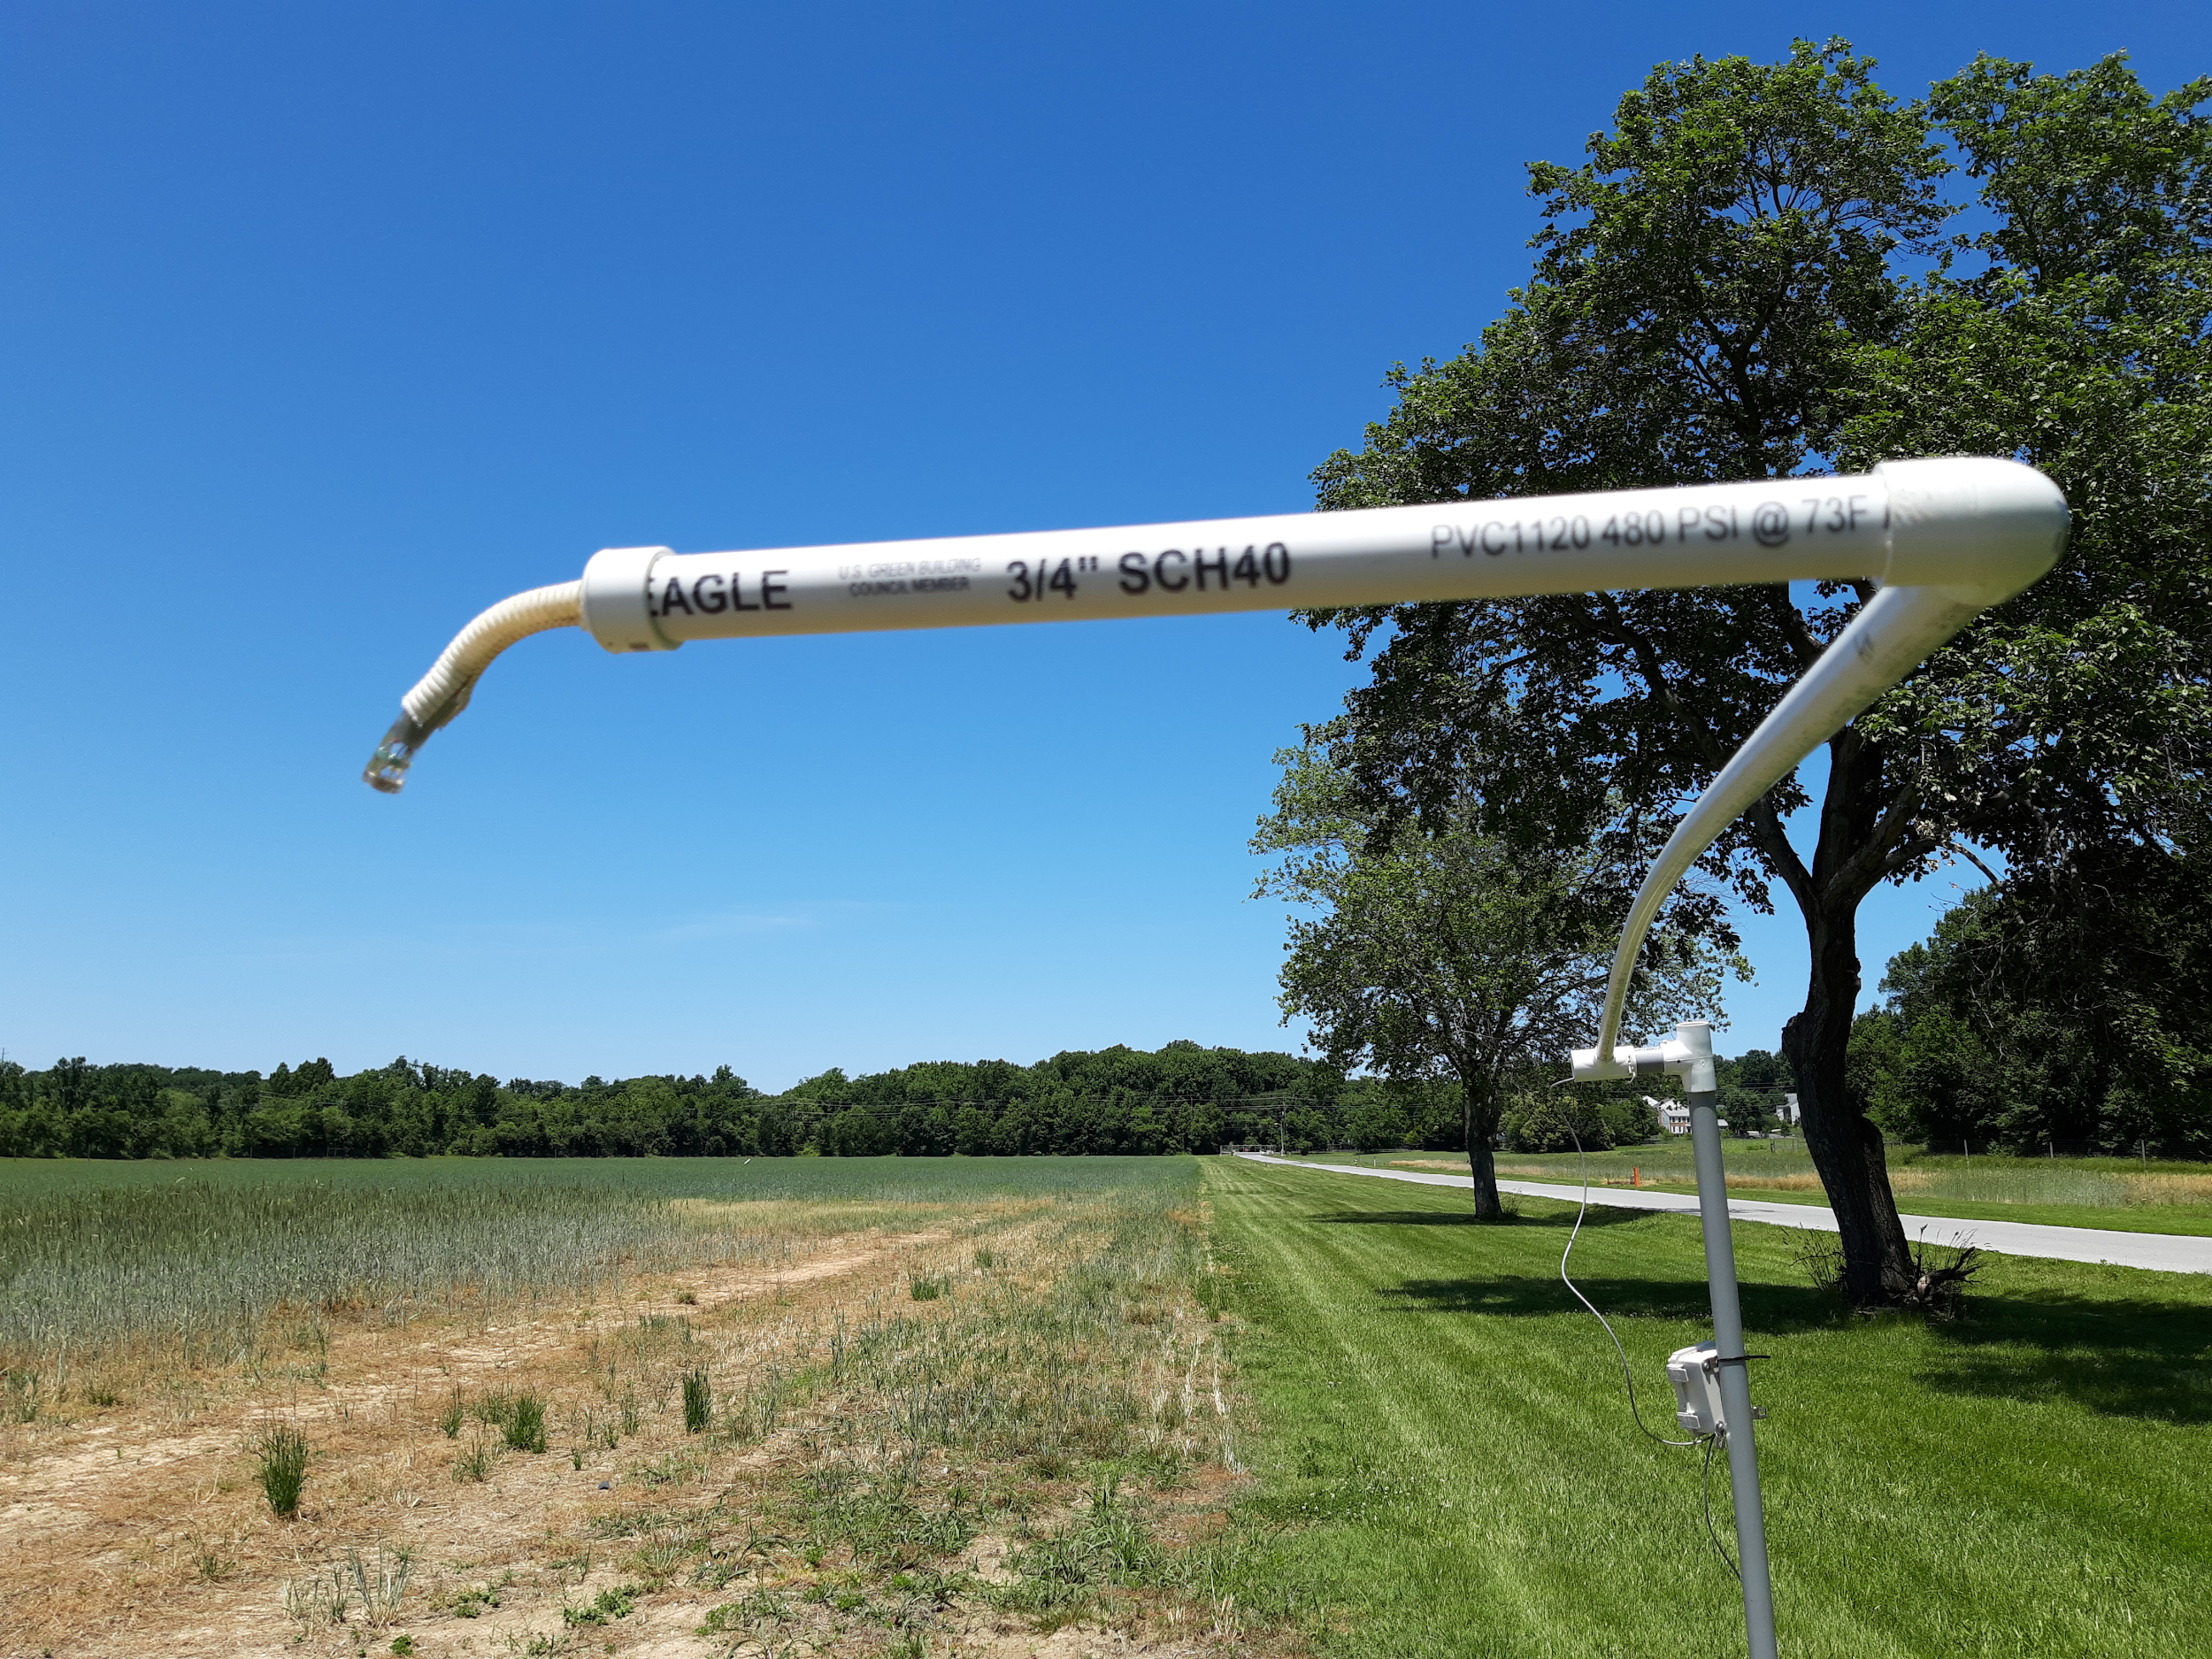

Figure 4. 90 degree canopy sensor

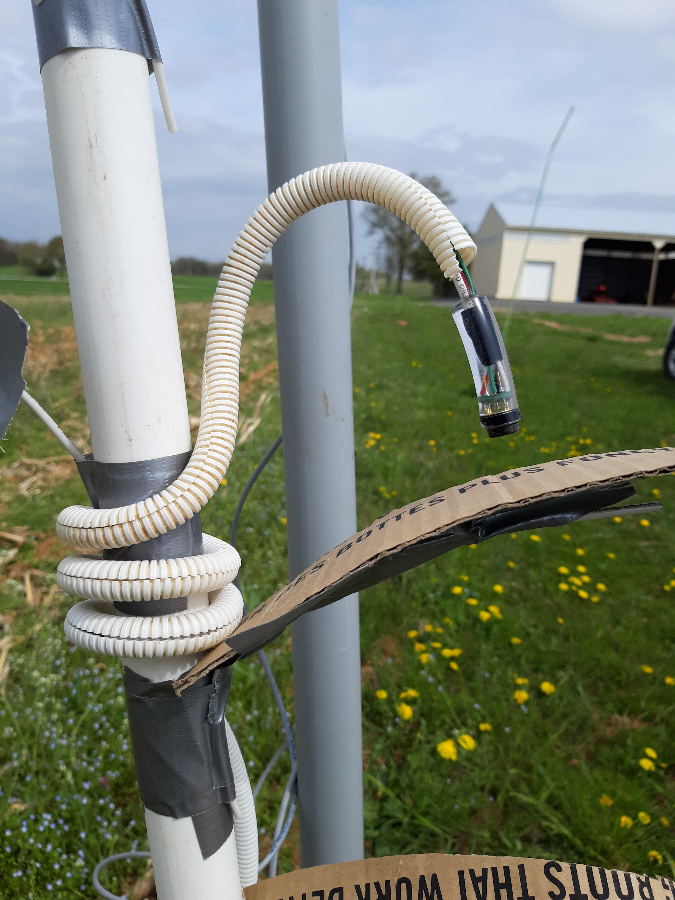

Figure 5. 35 degree “Snake” sensor aimed at makeshift cardboard corn leaf

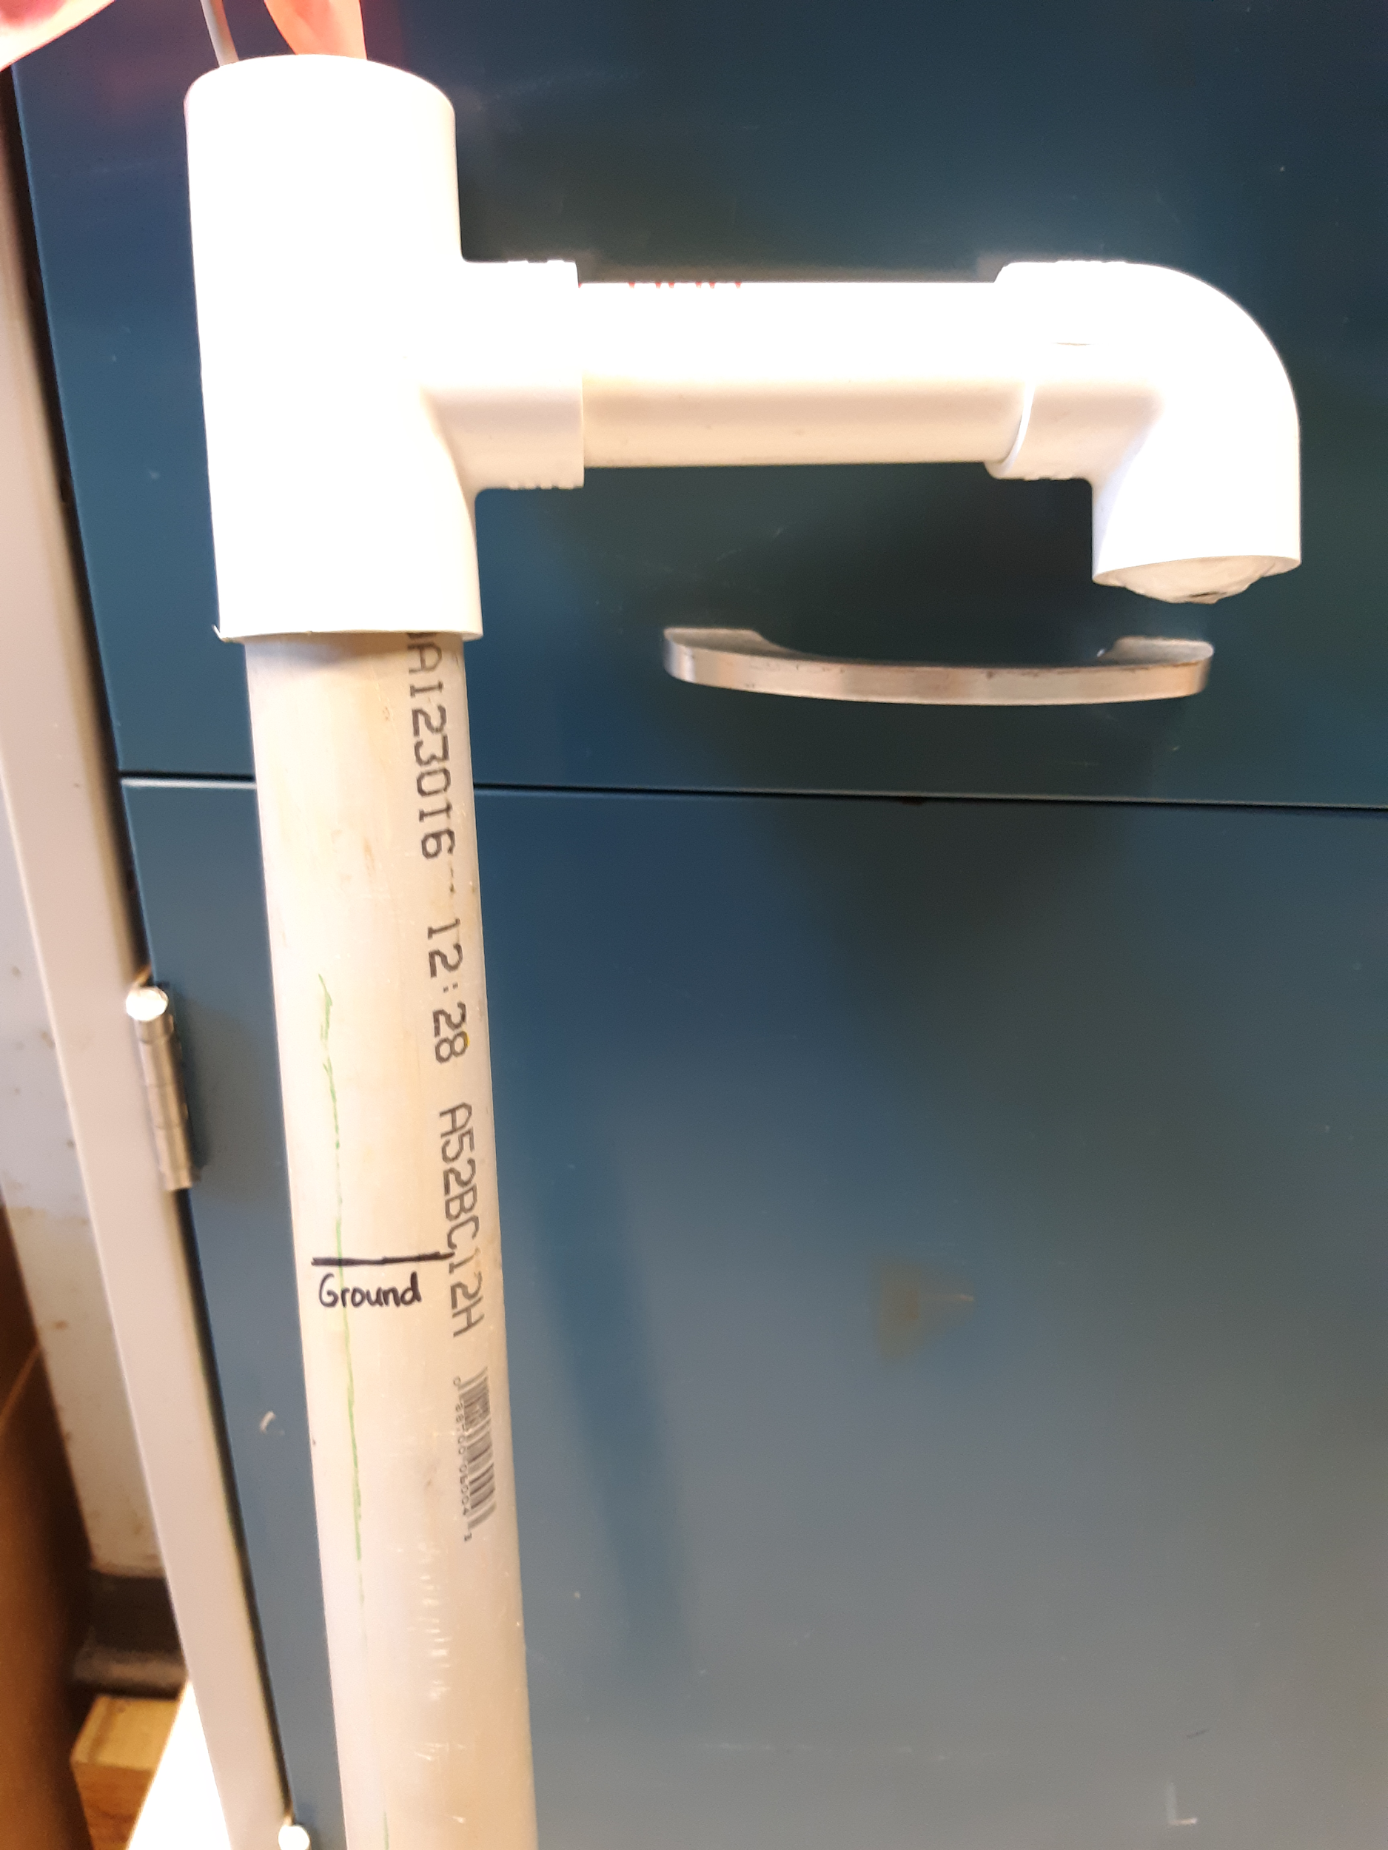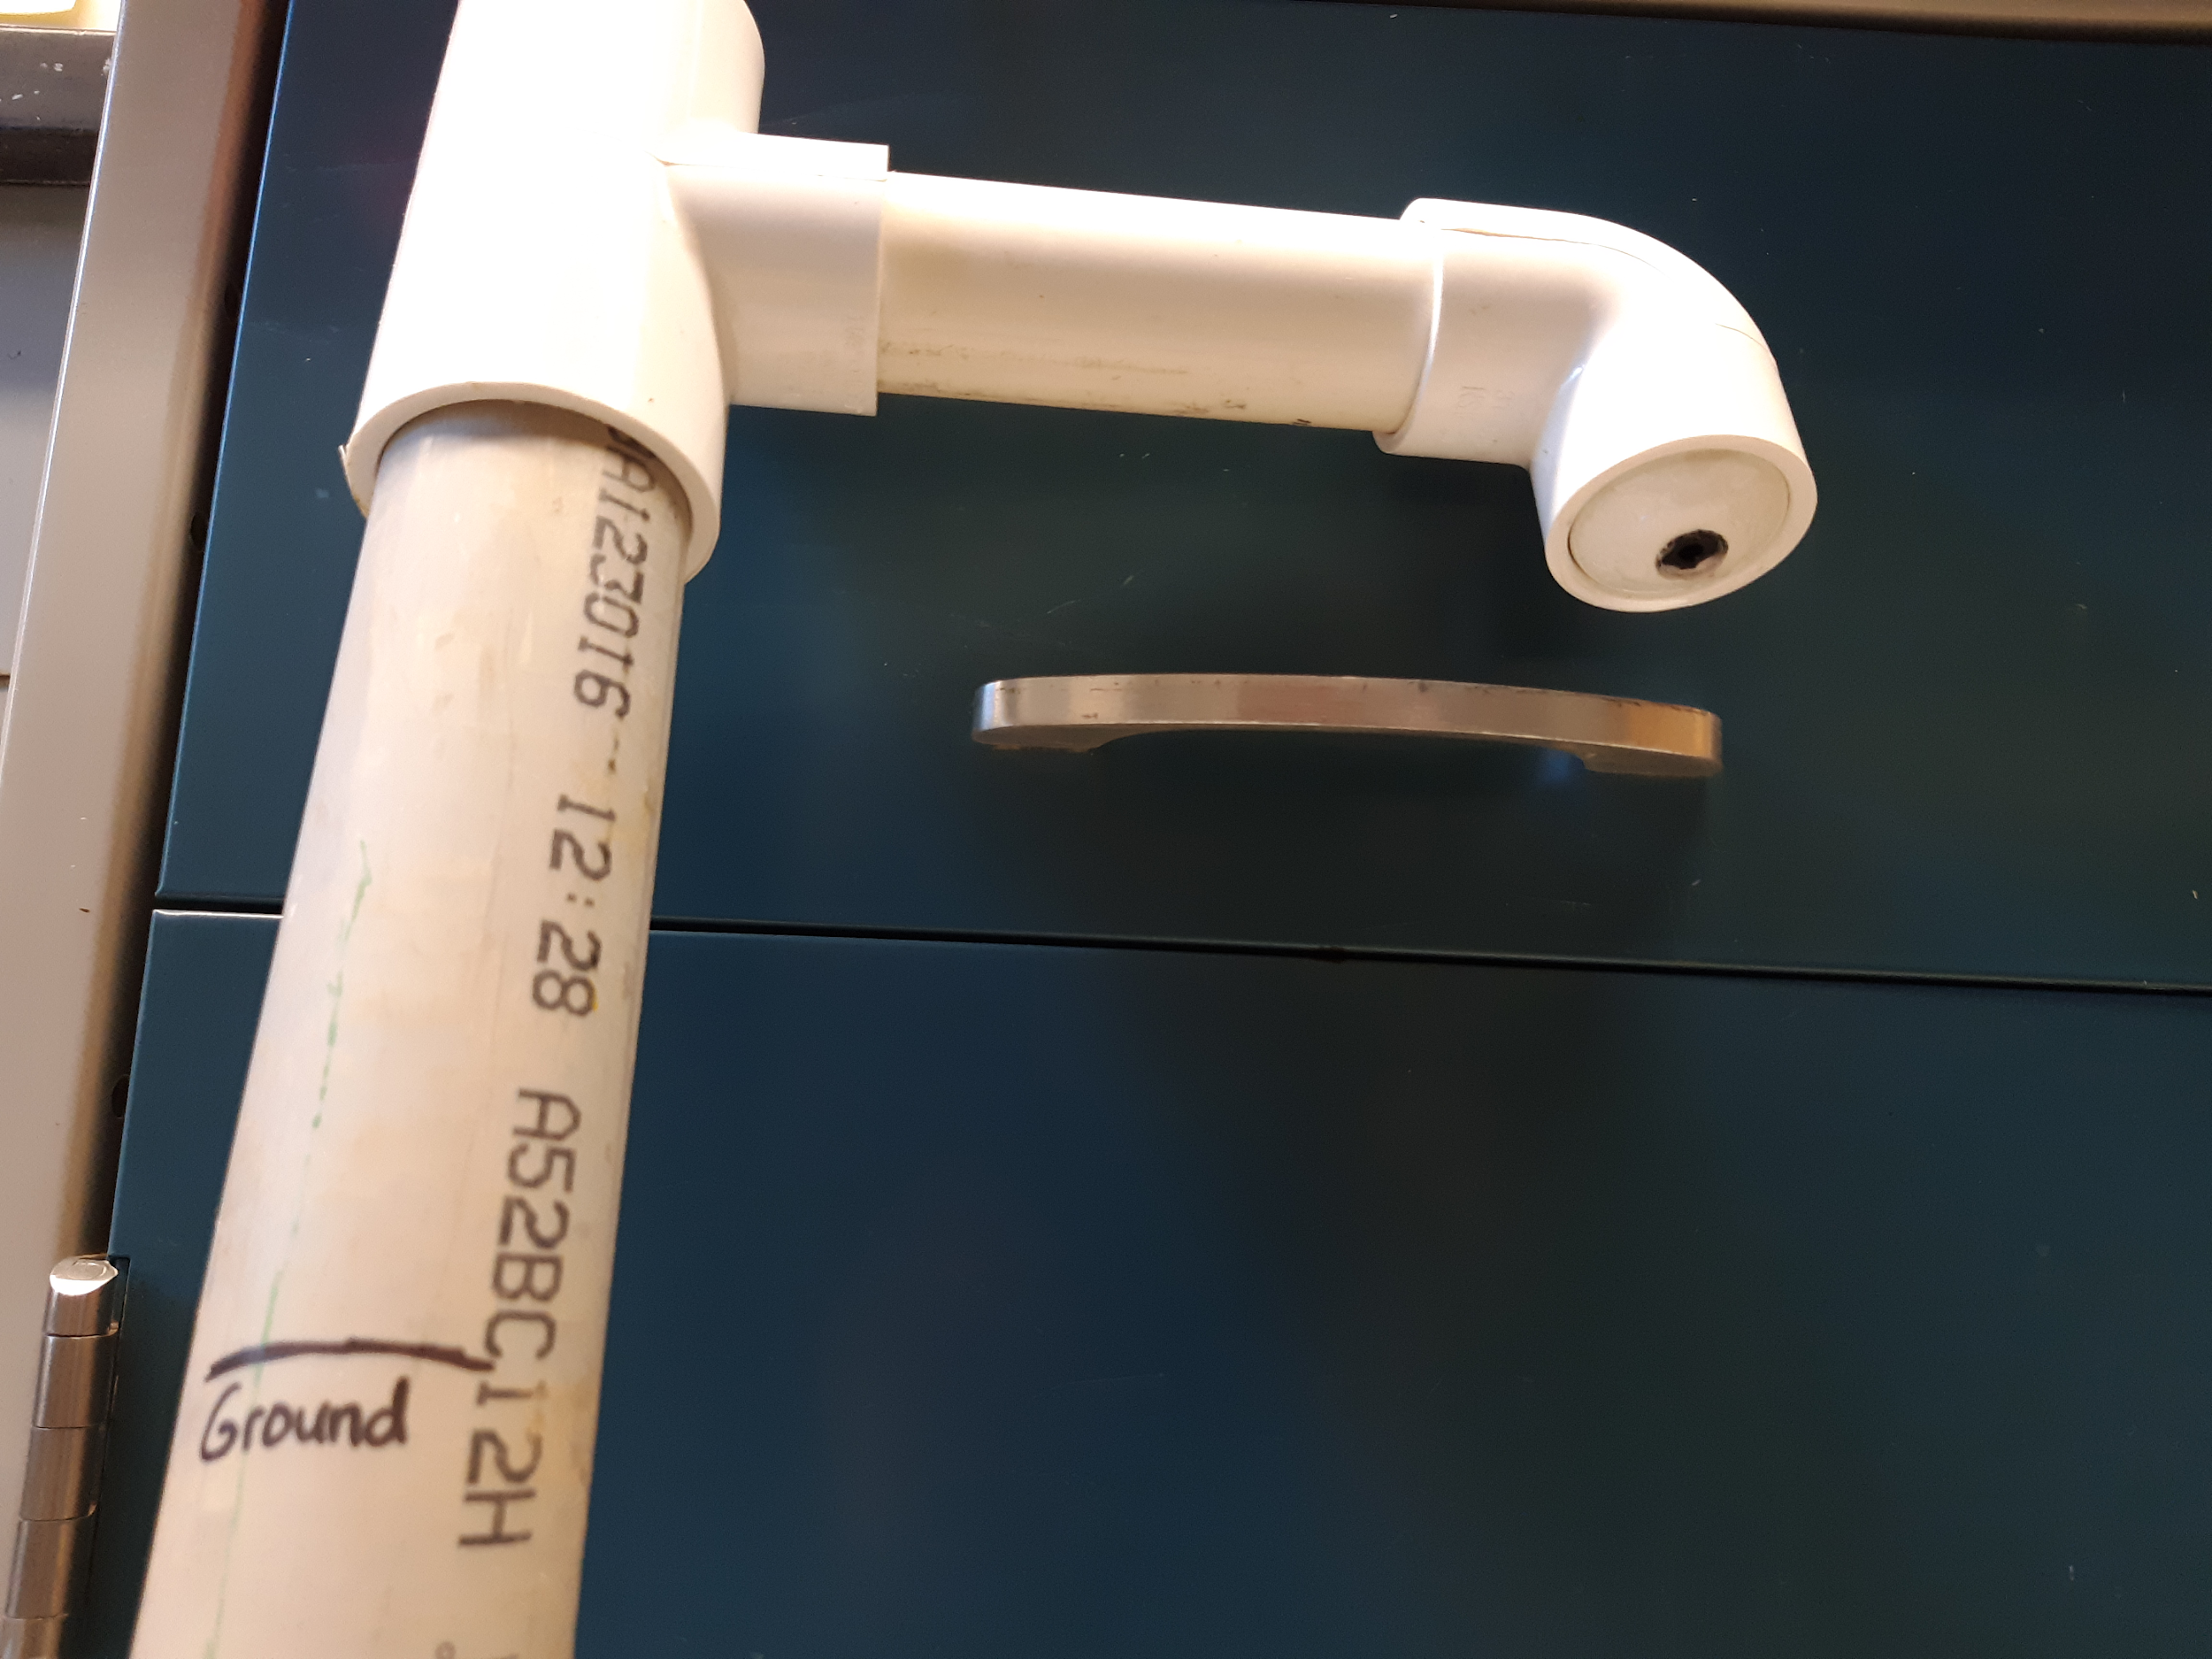

Figure 6. 35 degree soil sensor